|  |  |  |
| --- | --- | --- |
| DESIGN DOCUMENT | January 1  2015 | |
| LUDO WCF APPLICATION | | GROUP 6: Todor Tsekov Ivana Raykova Zair Thiel |

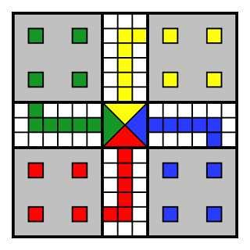

Table of Contents

1. Introduction 3

2. Architecture Design 4

3. Description of Interfaces 6

4. Class Diagram for client 7

5. Class diagram for Service 8

6. Sequence Diagrams for MUST use-cases 9

6.1 Roll Die 9

6.2 Place Token 10

6.3 In Game Chat 10

6.4 Move Piece 11

6.5 Remove Piece 12

6.6 Choose Color 13

6.7 Create Game 14

6.8 Start Game 15

6.9 Invite Player 16

# Architecture Design

LudoServer(app)

LudoClient(app)

IGame

Client 1

ILobby

ILobbyCallback

IGameCallback

Client 2

# Description of Interfaces

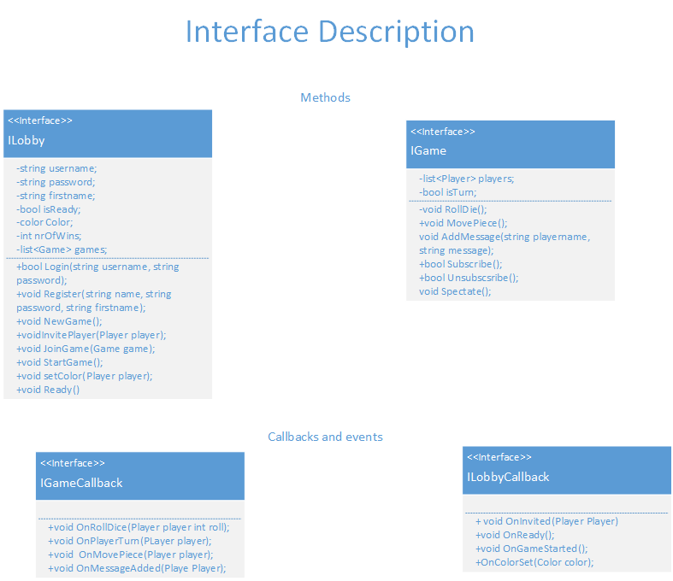

# Class Diagram for client

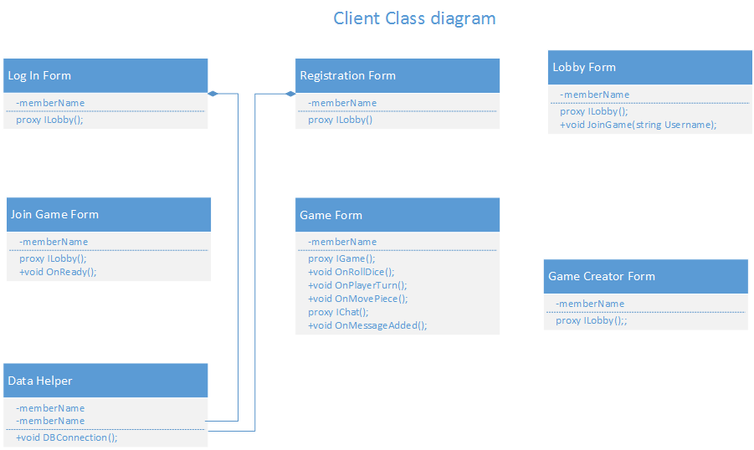

# Class diagram for Service

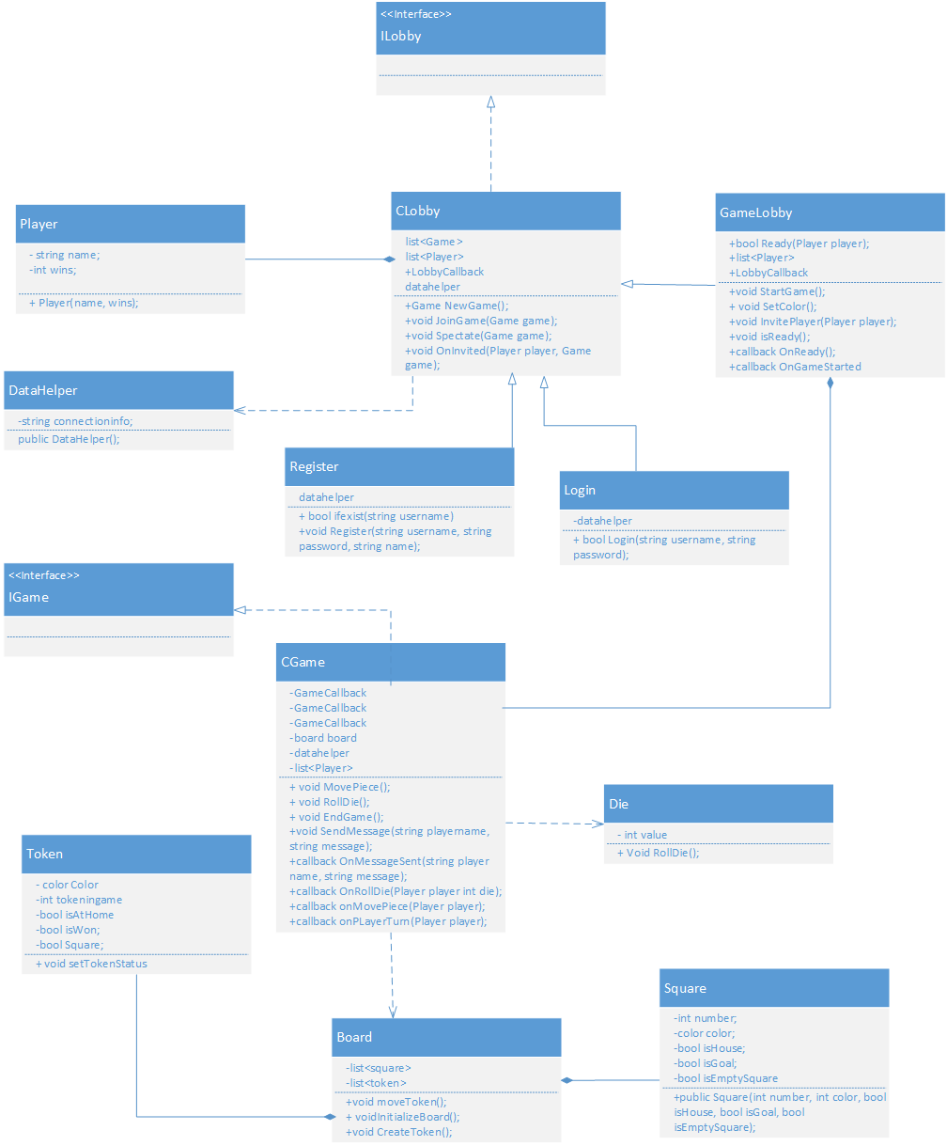

# Sequence Diagrams for MUST use-cases

## Roll Die

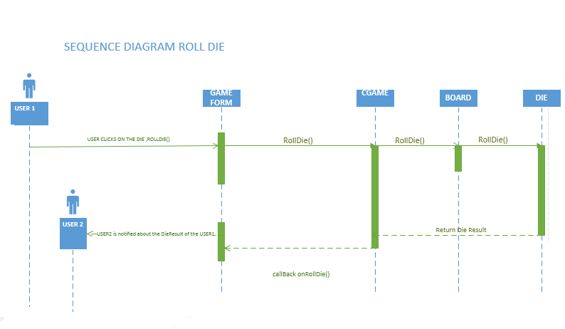

## 6.2 Place Token

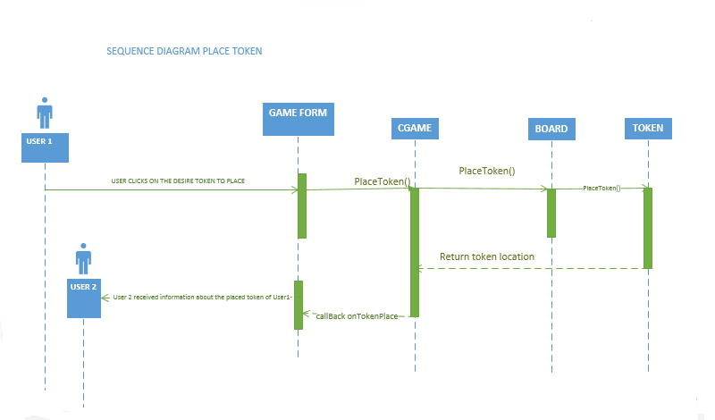

## 6.3 In Game Chat .

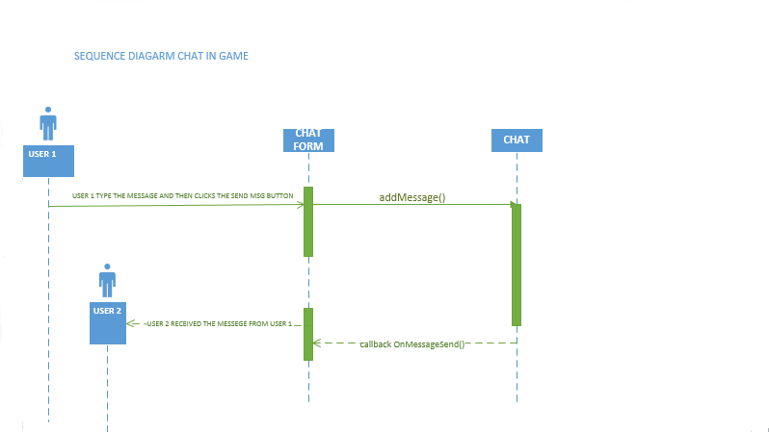

## 6.4 Move Piece

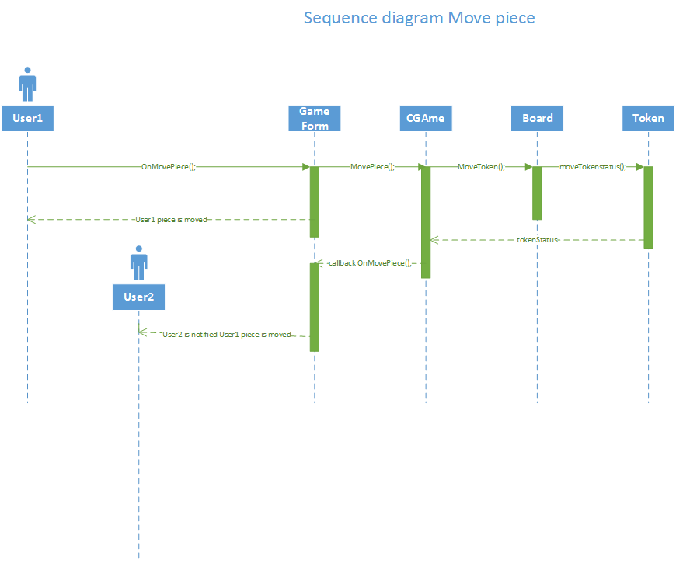

## 6.5 Remove Piece

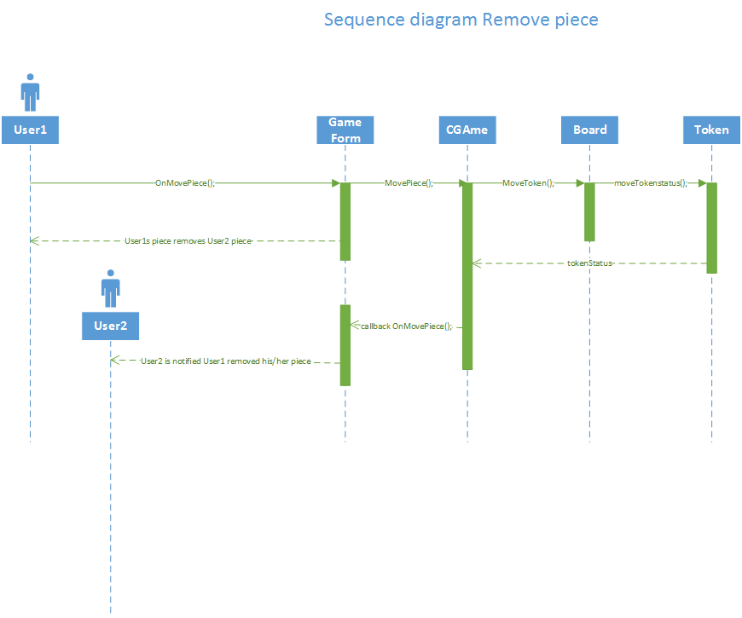

## 6.6 Choose Color

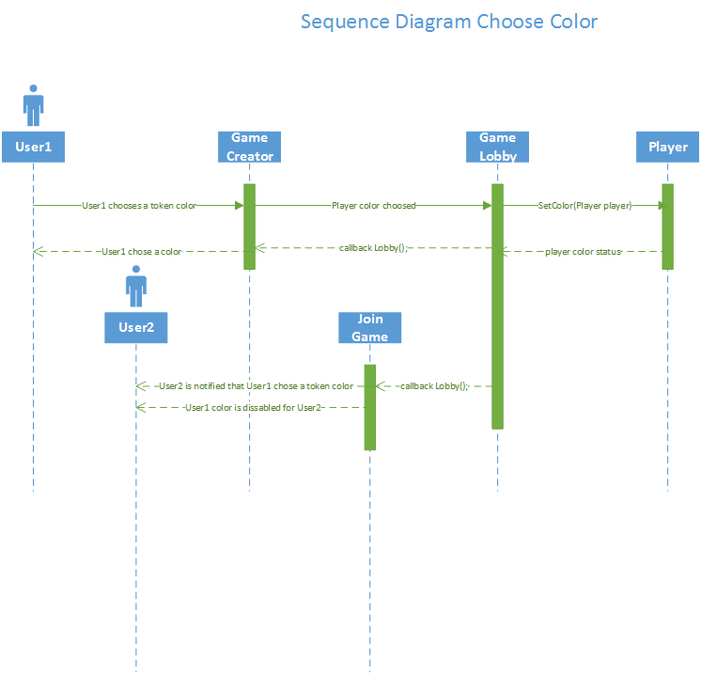

## 6.7 Create Game

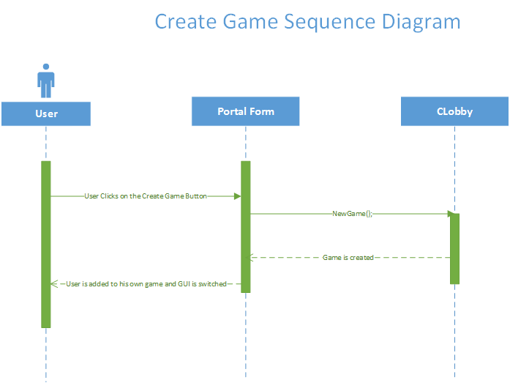

## 6.8 Start Game

## J:\MDW\Design Document\StartGame Sequence Diagram.png

## 6.9 Invite Player

## J:\MDW\Design Document\Invite Player Sequence Diagram.png